TITLE OF THE PROJECT

DESIGN AND APPLY CONTEXT-AWARE ACCESS CONTROLS BASED ON USER IDENTITY, DEVICE POSTURE, LOCATION, AND APPLICATION RISK.

LIST OF TEAMMATES :

Name : Madonna Lidial.M

College:Bishop appasamy college of arts and science

Contact:madonnalidial@gmail.com

PROJECT DETAILS :

TITLE : Design And Apply Context-Aware Access Controls Based On User Identity, Device Posture, Location, And Application Risk.

INTRODUCTION :

In an era where the digital landscape is constantly evolving, organizations face an ever-increasing threat from cyberattacks. The need for swift and effective incident response has become paramount to safeguard sensitive data, protect digital assets, and maintain the trust of stakeholders. In response to this growing challenge, we present a visionary project: the development of an AI-driven incident response platform that empowers cybersecurity teams with the tools to automate and enhance incident triage and response tasks.
The traditional network perimeter has all but dissolved in the modern digital landscape. With the mass adoption of cloud services, remote work, and personal mobile devices (BYOD), corporate resources are no longer confined to a single office building. This shift has rendered the conventional "castle-and-moat" security model—where anyone inside the network is trusted by default—obsolete and dangerously insufficient. Modern organizations now face the complex challenge of securing access to sensitive data from a diverse and ever-changing array of locations, devices, and user environments. To address this, security strategies must evolve from static, location-centric models to dynamic, identity-centric frameworks that assess the risk of every access request in real-time.
This project focuses on the design and implementation of a context-aware access control system to solve this exact challenge. By moving beyond simple username and password verification, this system will evaluate a rich set of contextual signals before granting access to applications and data. These signals include the user's identity and role, the security posture of their device (e.g., is it patched, encrypted, and managed?), their geographic location, and the inherent risk level of the application they are attempting to use. By analyzing these factors in unison, the system can make a granular, real-time decision: grant full access, restrict access to certain features, require step-up authentication (like multi-factor authentication), or block the request entirely.
Ultimately, this project aims to build a security architecture that is both robust and frictionless. For example, a trusted employee accessing a low-risk application from a secured corporate laptop on the office network might have a seamless login experience. Conversely, that same employee attempting to access a critical financial system from an unpatched personal device in a foreign country would be met with additional security challenges or be completely blocked. This intelligent, adaptive approach not only significantly reduces the attack surface and protects against compromised credentials but also enables a secure and productive work environment for a modern, mobile workforce.

ABSTRACT :

The increasing adoption of cloud services, mobile computing, and hybrid work models has fundamentally broken the traditional network perimeter, rendering legacy access control models ineffective. Organizations now struggle to protect sensitive data from a growing attack surface, where threats can originate from compromised endpoints, unsafe locations, or malicious insiders. Static, binary decisions (allow or deny) are no longer sufficient to mitigate the sophisticated risks present in modern distributed environments. There is a critical need for a dynamic security framework that can evaluate the full context of every access request in real-time.
This project presents the design and application of a context-aware access control system based on user identity, device posture, geolocation, and application risk. The objective is to develop a policy engine that ingests multiple contextual signals to calculate a real-time risk score for each access attempt. The methodology involves defining granular policies that map specific context combinations (e.g., "managed device" + "corporate network" + "low-risk app") to corresponding access decisions, such as granting full access, enforcing step-up authentication (MFA), limiting session functionality, or denying access entirely.
The expected outcome is an adaptive security model that significantly reduces the organizational attack surface and mitigates the risk of credential compromise.
By ensuring that access decisions are dynamically aligned with the perceived threat level of each request, the system enhances security without introducing unnecessary friction for low-risk, trusted users. This approach provides a robust framework for enabling secure and productive access to resources in an increasingly perimeter-less and dynamic digital world.

USE CASE SCENARIOS :

Scenario 1: Finance Department Access to ERP System
A senior accountant in the finance department needs to access the corporate Enterprise Resource Planning (ERP) system to process monthly payroll. The user connects from a remote location using their company-managed laptop. Upon launching the ZPA Client Connector, they authenticate via Azure Active Directory with multi-factor authentication (MFA). ZPA evaluates the user's identity, group membership (Finance_ERP_Users), device posture (antivirus active, disk encryption enabled), and connection context. The policy engine determines that the user is authorized and brokers a secure, direct micro-tunnel to the ERP application only. The user can interact with the ERP interface, but has no visibility or network-level access to any other internal systems, such as development servers or the HR database.
Output:
- User authenticated and authorized based on identity and group membership
- Direct micro-tunnel established specifically to the ERP application
- All other internal applications and network segments remain invisible and inaccessible

Scenario 2: Contractor Access to Specific Project Repository
An external software consultant is hired for a three-month project and requires access only to a specific Git repository hosted on an internal server. The contractor is onboarded as a guest user in the identity provider and assigned to the "Project_X_Contractors" group. When the contractor connects using the ZPA client, the system verifies their identity and checks the device for basic security compliance (OS patch level, firewall enabled). ZPA enforces a policy that grants access exclusively to the Git repository application (port 22/SSH or port 443/HTTPS) during business hours (9 AM to 5 PM). The contractor can clone, push, and pull code, but cannot discover or connect to any other internal resources, including the corporate intranet or file servers.
Output:
- Time-bound and role-specific access enforced
- Contractor restricted to a single application (Git repository)
- Lateral movement to adjacent systems completely blocked

Scenario 3: Executive Access to Sensitive Financial Documents
A company VP needs to access a folder containing confidential M&A documents stored in a corporate SharePoint site. The user connects from a hotel business center while traveling internationally, using their company-managed tablet. Upon launching the ZPA Client Connector, they authenticate via Azure Active Directory with MFA. ZPA evaluates the user's identity, executive group membership, and device posture (which is compliant). However, the geolocation (unusual foreign country) and the application risk (highly sensitive document repository) trigger an elevated risk score. The policy engine grants access to the SharePoint site, but enforces additional restrictions: download and print capabilities are disabled, and the session is monitored for unusual behavior (e.g., mass download attempts). An alert is also sent to the security team for high-risk executive login.
Output:
- User authenticated with MFA and device compliant, but flagged for unusual location
- Read-only access granted with download/print restrictions enforced
- Security team alerted to potential credential misuse or espionage attempt

Scenario 4: Remote Support Technician Access to Internal Tools
An IT support technician needs to access the corporate ServiceNow instance and a remote desktop tool to assist an employee. The technician connects from their home office using a company-managed desktop. Upon launching the ZPA Client Connector, they authenticate via Azure Active Directory with MFA. ZPA evaluates the user's identity, group membership (IT_Support), device posture (fully compliant), and connection type (home office, which is whitelisted for IT staff). Because the user, device, and location all meet the信任 baseline, the policy engine grants direct micro-tunnel access to both ServiceNow and the specific remote desktop jump host used for employee support. The technician can perform their duties efficiently, but still has no access to finance systems, HR databases, or source code repositories.
Output:
- User authenticated and fully authorized based on trusted context
- Direct micro-tunnels established to ServiceNow and the remote desktop jump host
- Least-privilege access maintained; unrelated internal systems remain invisible

Scenario 5: High-Risk Application Access from a Low-Trust Location
A marketing coordinator needs to access the corporate Salesforce instance to update a campaign. The user connects from a coffee shop using their company-managed smartphone. Upon launching the ZPA Client Connector, they authenticate via Azure Active Directory with MFA. ZPA evaluates the user's identity, group membership (Marketing_Salesforce_Users), device posture (managed and compliant), but flags the public Wi-Fi network as a high-risk connection. The policy engine determines that while the user and device are trusted, the network environment introduces unacceptable risk for direct access to a customer-facing CRM containing sensitive lead data. Instead of blocking access entirely, the user is routed through a secure ZPA browser isolation service, rendering the Salesforce session in a disposable container that prevents any data from persisting on the device or being exposed to the public network.
Output:
- User authenticated and device compliant, but network location deemed high-risk
- Access granted via browser isolation to prevent data leakage on public Wi-Fi
- Session is rendered in a secure container with copy/paste and download controls enforced

STAGE – 1

TITLE : owasp top 10

OVERVIEW :

The OWASP Top 10, published by the Open Worldwide Application Security Project (OWASP), is a globally recognized list that identifies the most critical security risks affecting web applications. It serves as a standard awareness document for developers, security professionals, and organizations to understand common vulnerabilities that attackers frequently exploit. The list is created using real-world data collected from thousands of applications and is updated periodically to reflect the evolving threat landscape. The OWASP Top 10 highlights major security issues such as broken access control, cryptographic failures, injection attacks, security misconfiguration, and server-side request forgery, which can lead to serious consequences including data breaches, unauthorized access, financial loss, and damage to an organization’s reputation. By following the OWASP Top 10 guidelines, organizations can improve their secure development practices, perform better security testing, and build more secure and reliable web applications.

LIST OF VULNERABILITY TABLE :

S.no | Vulnerability Name | CWE/CVE - No
1 | Improper Access Control | 284
2 | Cleartext Transmission of Sensitive Information | 319
3 | SQL Injection | 89
4 | Cleartext Storage of Sensitive Information | 312
5 | XML External Entity (XXE) | 611
6 | Use of Unmaintained Components | 1104
7 | Improper Authentication | 287
8 | Deserialization of Untrusted Data | 502
9 | Insufficient Logging | 778
10 | Server Side Request Forgery | 918

REPORT:
- Vulnerability Name: XML External Entity (XXE)
CWE/CVE: 611
OWASP/SANS Category: Broken Access Control
Description: Broken Access Control occurs when an application does not properly enforce restrictions on what authenticated users are allowed to do. Attackers can access other users’ data, modify records, or perform administrative actions.
Business Impact:
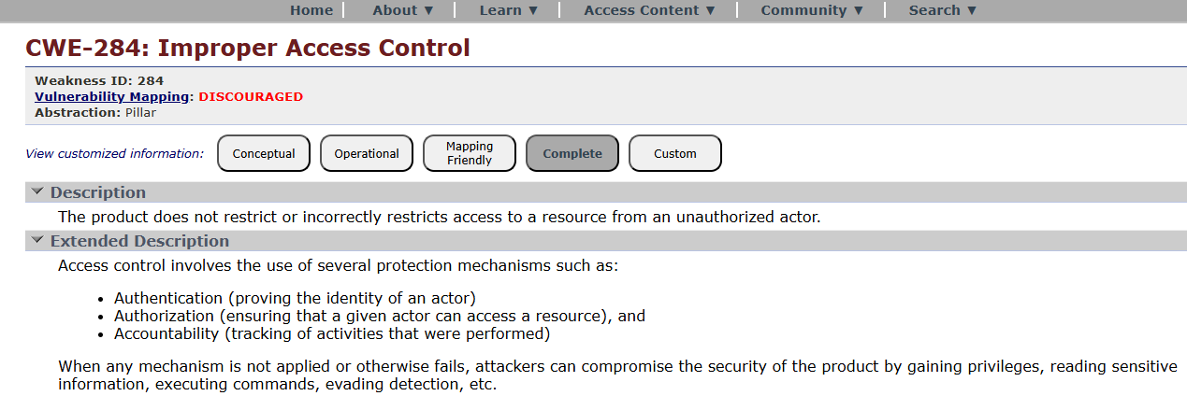
- Vulnerability Name: Cleartext Transmission of Sensitive Information
CWE/CVE: 284
OWASP/SANS Category: Cryptographic Failures
Description: Cryptographic failures occur when sensitive data such as passwords, credit cards, or personal information is not properly encrypted or protected.
Business Impact:
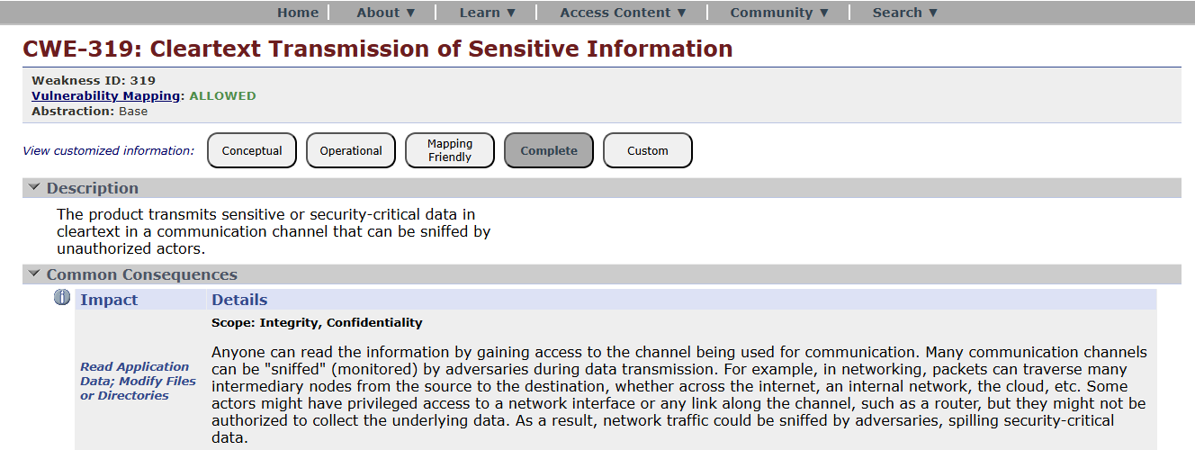
- Vulnerability Name: SQL Injection
CWE/CVE: 89
OWASP/SANS Category: Injection
Description: Injection flaws occur when untrusted user input is sent to an interpreter (SQL, OS commands, LDAP, etc.) without proper validation. Attackers can execute malicious commands.
Business Impact:
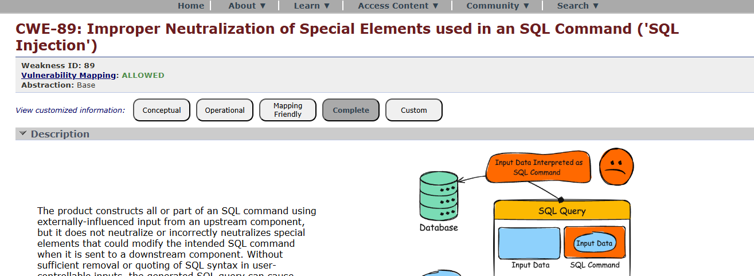
- Vulnerability Name: Cleartext Storage of Sensitive Information
CWE/CVE: 312
OWASP/SANS Category: Insecure Design
Description: Insecure design refers to flaws in system architecture or design that cannot be fixed simply by coding corrections.
Business Impact:
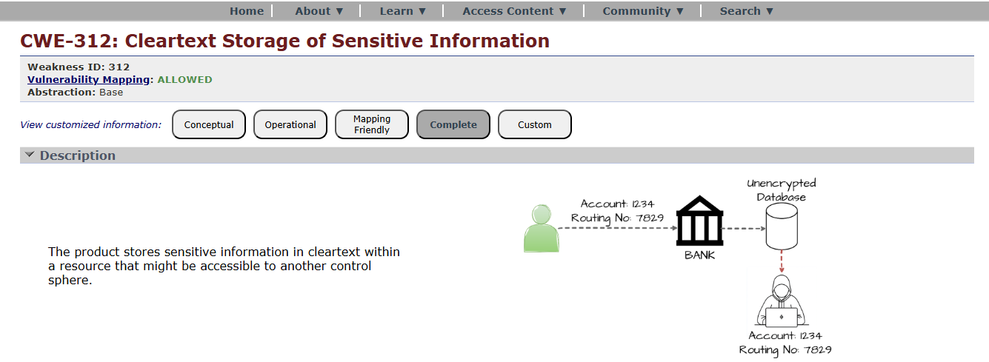
- Vulnerability Name: XML External Entity (XXE)
CWE/CVE: 611
OWASP/SANS Category: Security Misconfiguration
Description: Security misconfiguration occurs when security settings are incorrectly configured or left at default values.
Business Impact:
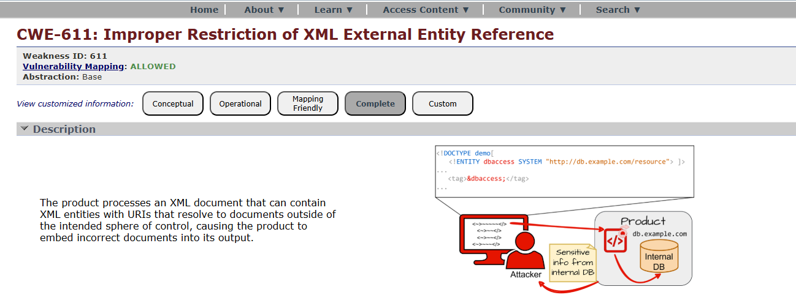
- Vulnerability Name: Use of Unmaintained Components
CWE/CVE: 1104
OWASP/SANS Category: Vulnerable and Outdated Components
Description: Applications may use libraries, frameworks, or software components with known vulnerabilities.
Business Impact:
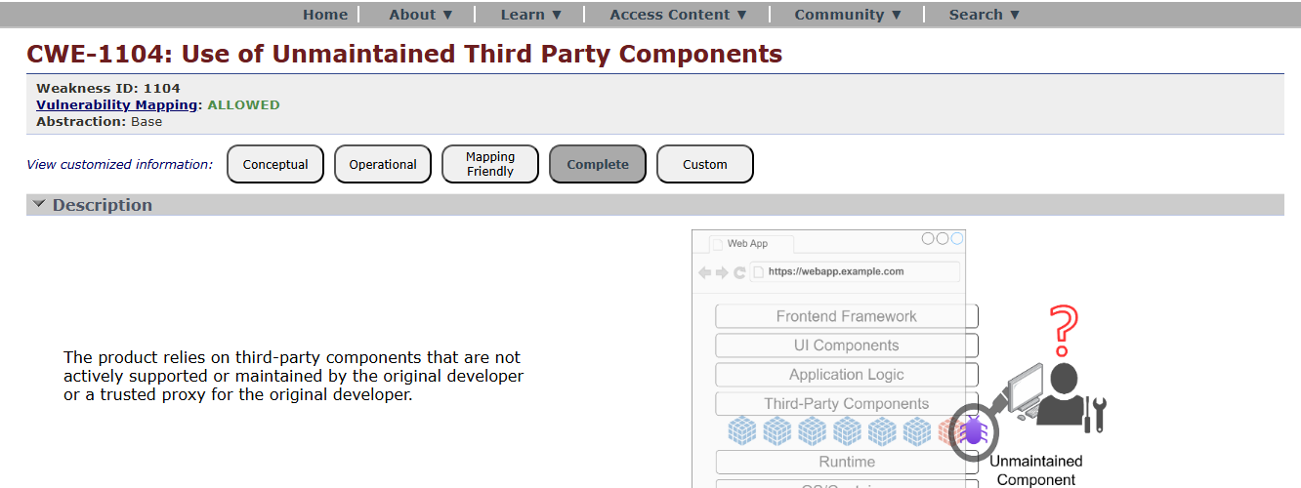
- Vulnerability Name: Improper Authentication
CWE/CVE: 287
OWASP/SANS Category: Identification and Authentication Failures
Description: Occurs when authentication mechanisms are poorly implemented.
Business Impact:
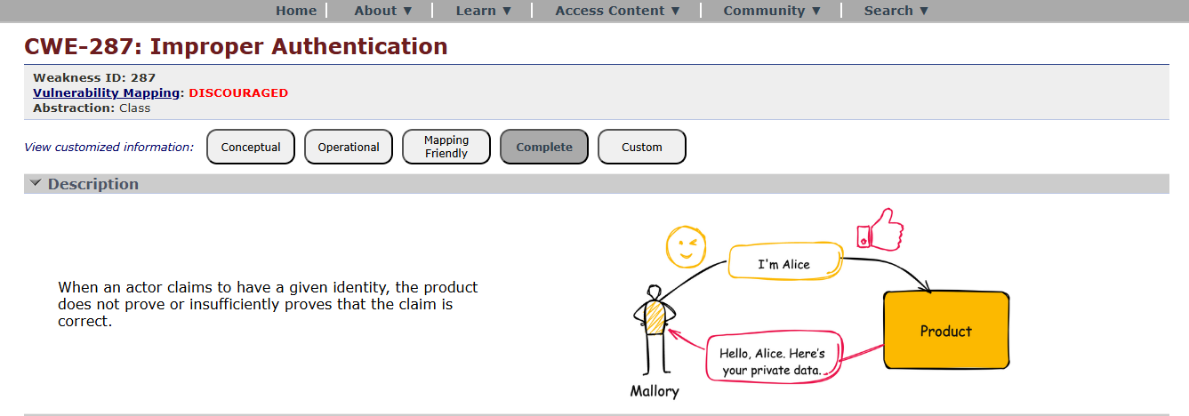
- Vulnerability Name: Deserialization of Untrusted Data
CWE/CVE: 502
OWASP/SANS Category: Software and Data Integrity Failures
Description: This vulnerability occurs when software updates or data are not verified for integrity.
Business Impact:
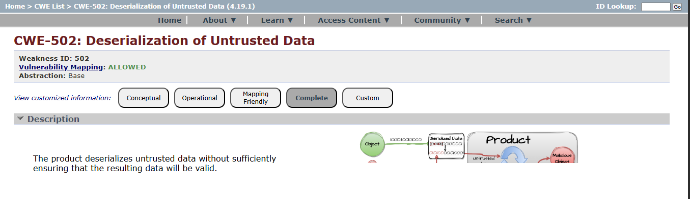

- Vulnerability Name: Insufficient Logging
CWE/CVE: 778
OWASP/SANS Category: Security Logging and Monitoring Failures
Description: Occurs when applications do not properly log security events or monitor suspicious activities.
Business Impact:
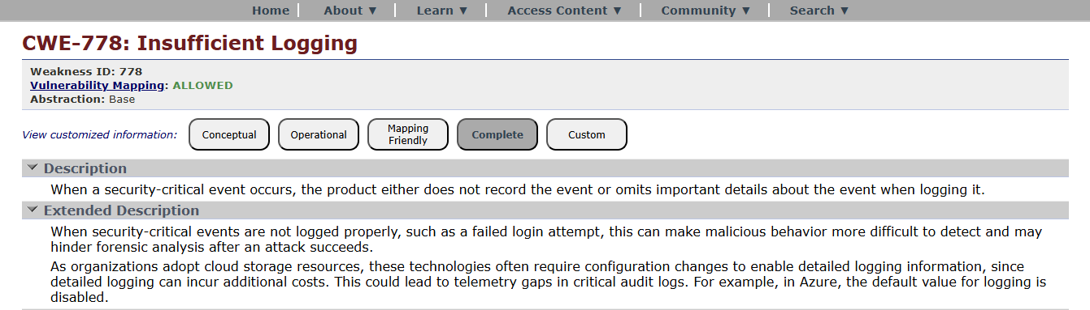
- Vulnerability Name: Server Side Request Forgery
CWE/CVE: 918
OWASP/SANS Category: Server-Side Request Forgery (SSRF)
Description: SSRF occurs when an attacker tricks the server into making requests to internal systems.
Business Impact:
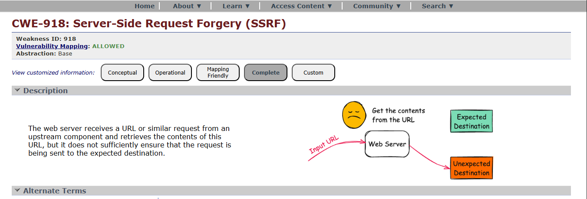

STAGE – 2
TITLE : Nessus Scanner
OVERVIEW :
Nessus scans are a critical component of proactive security, helping organizations identify and address vulnerabilities in their IT infrastructure to reduce the risk of security breaches and data compromises. The frequency and depth of scans can vary depending on an organization's security strategy and requirements.
Nessus is a popular vulnerability scanning tool used for identifying security weaknesses in computer systems and networks. It is widely utilized by security professionals and organizations to assess the security posture of their systems and to proactively identify potential vulnerabilities that could be exploited by attackers. Here's what I understand about Nessus scans:
Vulnerability Assessment: Nessus performs a vulnerability assessment by scanning target systems or networks to identify security issues, such as missing patches, misconfigurations, weak passwords, and other potential weaknesses that could be exploited by attackers.
Network Scanning: Nessus can scan a wide range of network devices, including servers, routers, switches, firewalls, and more. It examines network services, open ports, and software running on target systems.
Plugin Architecture: Nessus uses a plugin-based architecture, allowing it to check for a wide variety of vulnerabilities. These plugins are regularly updated to include the latest security checks and support for new vulnerabilities.
Compliance Auditing: It can also be used to assess systems against various compliance standards and regulatory requirements, helping organizations ensure that their systems meet specific security standards, like PCI DSS or CIS benchmarks.
Customization: Nessus scans can be customized to suit the specific needs of an organization. Users can define scan policies, select the target systems, and specify the types of vulnerabilities to scan for.
Reporting: Nessus provides detailed reports that highlight vulnerabilities, their severity, and remediation recommendations. These reports are essential for IT and security teams to prioritize and address vulnerabilities.
Scanning Frequency: Organizations often perform regular Nessus scans to continuously monitor and improve their security posture. This is crucial for staying ahead of evolving threats and vulnerabilities.
Integration: Nessus can be integrated with other security tools and platforms, allowing organizations to automate the scanning process and streamline their vulnerability management.
Licensing: Nessus offers both free and commercial versions. The free version is limited in its functionality, while the commercial version provides more features and support.
User-Friendly Interface: Nessus offers an easy-to-use web-based interface, making it accessible to a wide range of users, from security experts to less experienced IT professionals.

TARGET WEBSITE : testfire.net
TARGET IP ADDRESS : 54.83.41.36

LIST OF VULNERABILITY :
S. No | Vulnerability Name | Severity | Plugins
1. | Cross-site scripting (stored) | Low | Web application Scanner
2. | Broken Access Control | Medium | SSH weak HMAC Algorithms Supported
3. | SQL Injection | Medium | N/A
4. | Broken Authentication | Low | HSTS Missing from Server
5. | Insecure Direct Object Reference | Info | Service Detection
6. | Security Misconfiguration | Low | SSL cipher Block Chaining cipher suites
7. | Cross-Site Request Forgery | Low | HTTP Form- Based Authentication Detected
8. | Cleartext Transmission of  Sensitive Information | Medium | Cleartext Transmission of Sensitive  Information over HTTP
9. | ClickJacking | Info | HTML Rendering Layer Vulnerability
10. | webserver allows password auto- completion | Low | SSL/TLS Diffie-Hellman Modulus<=1024 bits(Logjam)

STAGE – 3
TITLE : Design and apply context-aware access controls based on user identity, device posture, location, and application risk.
OVERVIEW : In response to the evolving threat landscape and the dissolution of the traditional network perimeter, modern enterprises are rapidly shifting away from legacy VPN-centric remote access models. These conventional approaches often grant excessive network-level access, creating a significant attack surface and increasing the risk of lateral threat movement. To address these challenges, this project centers on the implementation of a Zero Trust security architecture, fundamentally operating on the principle of "never trust, always verify." By moving beyond location-based access, we aim to establish a security posture where trust is no longer implicit, and access is determined by granular context rather than network connectivity.
The core of this initiative involves the deployment of Zscaler Private Access (ZPA), a cloud-delivered Zero Trust Access solution designed to create identity-aware, application-specific connectivity. Unlike traditional VPNs that place users on the internal network, ZPA leverages a "service-initiated" model to establish direct, one-to-one connections between authorized users and specific applications, completely hiding the corporate network and IP address space from the internet. This ensures that users connect exclusively to the applications they are permitted to access, based on continuous identity verification and context, rendering the applications invisible to unauthorized users and preventing common attack vectors such as port scanning and distributed denial-of-service (DDoS) attacks.
Ultimately, this project will enforce a least-privilege access model, ensuring users and devices are granted the minimum required access necessary to perform their functions. By decoupling application access from network access, we will eliminate the risk of lateral movement across the network, as users have no visibility or connectivity to other hosts. This strategic move not only significantly enhances security by reducing the attack surface but also simplifies the user experience and reduces operational overhead associated with legacy remote access infrastructure, positioning the organization at the forefront of secure and efficient access management.
CONTEXT-AWARE ACCESS CONTROL: Context-aware access controls represent the operational pinnacle of a Zero Trust architecture, moving beyond static rules to create a dynamic and adaptive security perimeter around every application. In a modern enterprise, where users are mobile, devices are diverse, and threats are sophisticated, granting access based solely on a username and password is a dangerous oversimplification. Designing and applying context-aware controls means building a policy engine that consumes multiple, real-time signals about an access request and renders an intelligent decision: to allow, to block, to limit, or to challenge. This approach ensures that the security posture is not a flat, always-on gate but a responsive system that tightens or loosens based on the risk of the specific moment.
USER IDENTITY : The design of such a system begins with a deep integration between the access broker, such as Zscaler Private Access (ZPA), and the organization's existing security and identity infrastructure. The first and most fundamental layer is user identity. This is not simply a username, but a rich set of attributes pulled from the corporate Identity Provider (IdP) like Azure AD or Okta. Integration via SAML ensures that when a user authenticates through the ZPA client, they are verified with multi-factor authentication (MFA) by the IdP. ZPA then ingests not just the user's name, but their group memberships (e.g., "Finance – Payroll Managers," "Engineering – Source Code Contributors"), roles, and department. This allows for the creation of granular policies that are intrinsically tied to the user's function within the organization. For instance, a policy can be written in plain language: "Allow members of the 'Finance-Payroll' group to access the 'ADP Payroll' application."
DEVICE POSTURE : However, a valid identity on a compromised device is still a critical threat. This is where the second layer, device posture, becomes essential. The design incorporates continuous checks on the security health of the endpoint attempting the connection. Through integrations with Endpoint Detection and Response (EDR) tools like CrowdStrike or SentinelOne, and Mobile Device Management (MDM) solutions like JAMF or Intune, ZPA can assess a device's real-time hygiene. The policy engine evaluates factors such as: Is the device's disk encryption (BitLocker/FileVault) enabled? Is the antivirus software active and its definition database up-to-date? Has the operating system been patched to the latest security baseline? Is the device rooted or jailbroken? Is there a high-risk score being reported by the EDR tool due to suspicious activity? If a device fails these checks—for example, a user's laptop has its firewall disabled—the context-aware policy can automatically trigger an action. It might block access entirely, or it might grant "remediation access," routing the user to a captive portal to download updates or contact IT, while preventing them from reaching any business-critical applications. This ensures that a vulnerable endpoint cannot become a beachhead for an attacker to move laterally into the corporate environment.
LOCATION : The third contextual layer is location and network environment. The physical or virtual location from which a user connects provides a powerful signal for risk assessment. A finance director accessing the payroll system from their home office in the same city is a low-risk event. The same user attempting to connect from a country with a high prevalence of cybercrime, or from an anonymizing VPN service, should be treated with extreme suspicion. Context-aware policies can be designed to enforce this logic. For example, access to a source code repository containing intellectual property could be restricted to users connecting from a corporate office or a pre-approved home IP address range. If a legitimate user is traveling, the policy might allow access but require a step-up authentication, such as a hardware token, or grant only read-only permissions. This layer can also consider the security of the network itself; a connection from a public, unencrypted Wi-Fi hotspot might trigger stricter controls than one from a known, secure corporate network.
APPLICATION RISK : The final and often most strategic layer is application risk. Not all applications are created equal, and their access policies should reflect their value and sensitivity. In the design phase, applications are categorized and tagged based on their risk profile. An internal wiki used for cafeteria menus would be classified as low-risk, whereas a customer database, a financial trading platform, or a source code repository would be classified as high or critical risk. This tagging allows policies to be layered and dynamic. A single user might have access to multiple applications, but the controls applied to each session will differ based on the application's risk. For the low-risk wiki, a valid user identity and a compliant device might be sufficient. However, for the high-risk financial platform, the policy engine might require all four layers to align: the user must be in a specific group, on a fully patched and managed device, connecting from a trusted location, and may even be subject to session recording or time-of-day restrictions. This ensures that security resources and scrutiny are applied proportionally to the actual risk, preventing "blanket" access and ensuring that the most valuable assets have the most robust defenses.
CONCLUSION :
STAGE – 1: In conclusion, web application testing is a crucial process that ensures the security, functionality, and reliability of web-based software. It involves a comprehensive evaluation of various aspects, including user interface, functionality, performance, and security to identify and rectify issues before they impact end-users. This process not only enhances the quality of web applications but also bolsters their resilience against potential threats and vulnerabilities. In an age where online services and applications are integral to our daily lives, effective web application testing is essential to deliver a seamless and secure user experience.
STAGE – 2: The Nessus report for the specific website has highlighted key security insights. It identified vulnerabilities, categorized by severity, with a focus on critical and high-risk issues that need immediate attention. Recommendations for addressing these vulnerabilities include patching, reconfiguration, and other security measures, with a priority on actions that can have the most significant impact. Compliance with industry standards and best practices is considered, ensuring alignment with recognized security benchmarks like OWASP guidelines. The report underscores the need for continuous monitoring, regular updates, and ongoing security efforts to maintain a strong security posture. In summary, the Nessus report offers a clear view of the website's security state, provides guidance on mitigating vulnerabilities, and stresses the importance of sustained vigilance against evolving threats.
STAGE – 3: The implementation of Zscaler Private Access marks a pivotal shift from a vulnerable, network-centric security model to a resilient, identity-centric Zero Trust architecture. By enforcing least-privilege access and rendering private applications invisible to the internet, this project effectively neutralizes the threats of lateral movement and network-based attacks. The solution not only fortifies the organization's security posture against modern cyber threats but also delivers a seamless and high-performance experience for a distributed workforce. Furthermore, the decoupling of access from the network simplifies IT operations, reduces dependency on legacy VPN infrastructure, and provides granular visibility into user-application interactions. Ultimately, this initiative establishes a future-ready foundation for secure digital transformation.
FUTURE SCOPE :
STAGE – 1: Future scope of web application testing
The future scope of web application testing is promising and evolving rapidly, driven by the continuous growth of the internet and web-based applications.
Here are some key aspects of its future scope:
▪ Increased Demand: As more businesses and services move online, the demand for web applications continues to grow. This, in turn, increases the demand for web application testing to ensure security, reliability, and functionality.
▪ Advanced Technologies: The complexity of web applications is rising with the integration of advanced technologies like AI, IoT, and blockchain. Testing these cutting-edge applications will require specialized skills and tools.
▪ Security Emphasis: With the growing number of cyber threats and data breaches, security testing for web applications will become even more critical. Testers will need to focus on vulnerabilities, data protection, and compliance with regulations like GDPR.
▪ Mobile and Cross-Browser Testing: Mobile usage is on the rise, and web applications must be responsive and functional on various devices and browsers. Testing for cross-compatibility will be essential.
▪ Performance Testing: As user expectations for speed and performance increase, load testing, stress testing, and other performance testing types will be crucial to ensure web applications can handle traffic spikes.

STAGE – 2: Future scope of the testing process you understood.
The future scope of the web application testing process, particularly in terms of identifying vulnerabilities, is exceedingly promising due to the continuous growth of digital platforms, the escalating importance of cybersecurity, and the ever-evolving threat landscape. Here are some key aspects that highlight the prospective scope of web application testing for vulnerability discovery:
▪ AI-Driven Testing: The integration of artificial intelligence (AI) and machine learning (ML) into web application testing tools will revolutionize the way vulnerabilities are identified. AI algorithms can swiftly scan vast amounts of code and data to pinpoint vulnerabilities that might elude human testers.
▪ IoT and Mobile App Testing: With the proliferation of Internet of Things (IoT) devices and the increasing usage of mobile applications, the scope of web application testing will extend to encompass these areas. Ensuring the security of IoT devices and the interfaces they use will become critical.
▪ Blockchain and Cryptocurrency Security: As blockchain technology and cryptocurrencies continue to gain traction, security testing will be imperative to safeguard transactions and digital assets. Ensuring the robustness of blockchain-based applications will be a specialized niche in web application testing. Serverless Architectures: With the adoption of serverless computing, web application testing will need to adapt to assess the security of serverless functions and APIs. Ensuring that serverless components are free from vulnerabilities will be paramount.
▪ Container Security: As containerization technologies like Docker and Kubernetes become ubiquitous, web application testing will extend to cover container security. This includes ensuring that container images and orchestration configurations are free from vulnerabilities.

STAGE – 3: Future scope of Aware Access Control
The successful deployment of ZPA lays the groundwork for a broader, more integrated security ecosystem. Future enhancements can be explored to further mature the organization's security capabilities:
▪ Integration with Zscaler Internet Access (ZIA): Converging Private Access (ZPA) with Internet Access (ZIA) to create a unified Secure Access Service Edge (SASE) platform, managing all web and private traffic through a single policy framework.
▪ Advanced Device Posture Checking: Moving beyond basic compliance to incorporate real-time risk scores from EDR tools, blocking access if a device shows signs of active compromise.
▪ Privileged Remote Access: Extending ZPA to third-party vendors and contractors with time-bound, audited access to specific critical systems, replacing jump boxes and bastion hosts.
▪ IoT/OT Segmentation: Applying the same micro-tunneling principles to Internet of Things (IoT) and Operational Technology (OT) devices to ensure they can only communicate with specific management servers.
▪ AI-Driven Anomaly Detection: Leveraging machine learning on ZPA logs to detect behavioral anomalies, such as a user accessing an application at an unusual hour or from a strange location, triggering automated MFA challenges or access revocation.
▪ Cloud Workload Protection: Utilizing ZPA to secure connections between containers and microservices in multi-cloud environments (AWS, Azure, GCP), ensuring east-west traffic between workloads is encrypted and authenticated.
▪ Automated Provisioning/Deprovisioning: Enhancing the identity provider integration to automatically revoke application access the moment an employee is terminated or changes roles, ensuring near real-time access control.
▪ Digital Experience Monitoring (DEM): Implementing DEM tools to proactively monitor the end-user experience, identifying network latency or application performance issues before they impact productivity.
TOPICS EXPLORED : owasp top 10, scanning, vulnerabilities, application risk, access control, awareness, user identity, location.
TOOLS EXPLORED : Zscaler, owasp, Nessus, testfire.net.

